Slim Jim (J Integrated Match J-Pole) is probably the most easiest and powerful 2 meter antenna to build provided you have the exact measurement and material to build it.
This how to will show you how to build a 2 meter slim jim antenna from ordinary insulated copper wire commonly used for carrying AC (alternate current) electricity in your household.
Slim Jim construction basic
I am not only going show you the measurement of slim jim antenna for specific frequency, but I’m going to show you how to calculate slim jim antenna by your own using the basic formula below.
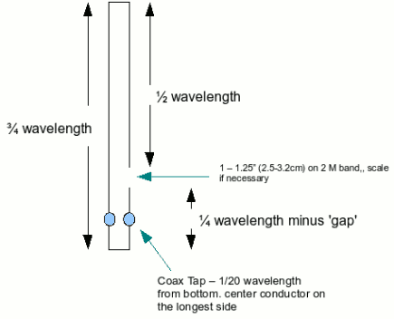
The figure above shows that the longest side of slim jim is 3/4 wavelength long and the shorter side of the slim jim consist of 1/2 wavelength and 1/4 wavelength long seperated by a gap.
The feedline (coax cable) is normally connected 1/20 wavelength from the bottom of the slim jim antenna with the center conductor connected to the longest side and the shield/braid is connected to the shorter side.
Building the Slim Jim antenna
This guide assume you want to build a slim jim antenna that centered on 146MHz.
Calculation
The formula for calculating wavelength in metric system is 300/(freq MHz)
Using the formula from the figure, we have :
300/146 = 2.055 M
Wavelength = 205.5 cm
Wavelength x copper wire velocity factor = 205.5 cm x 0.94
= 193.17 cm
3/4 wavelength = 193.17 x 0.75
= 144.88 cm (57″)
1/2 wavelength = 193.17 x 0.5
= 96.585 cm (38″)
1/4 wavelength minus gap = 193.17 x 0.25 – 2.6 cm
= 45.69 cm (18″)
Coax tap = 193.17 x 1/20
= 9.6 cm (3 3/4″)
Building Materials
- 3/4″ diameter PVC (20mm) – 6 feet (180 cm)
- ordinary insulated copper wire for carrying altenate current (AC) – 11 feet (3.40 meter)
- Cable ties
Tools
- Soldering iron
- Glue gun
- Somthing to make a hole on PVC pipe
Wire Slim Jim Building Steps
- First take the PVC pile and measure it according to the 3/4 wavelength formula above (144.88 cm).
- Make two holes at the opposite side of the pipe. This hole is used for putting the copper wire through the pipe. Repeat this step 144.88 cm away from the top hole. Both of these holes will hold the copper wire.
- Insert the wire through the hole until both end reaches each other on one side of the PVC pipe. Then measure the length of the wire and cut the wire on that side so the setup resembles the figure above.
- Cut the wire insulation (but leave the wire uncut) 1/20 wavelength away (9.6 cm) from the bottom of the PVC pipe, again refer the figure above.
- Solder the center of the coax cable at the longest side of the slim jim (3/4 wavelength part) and the braid/shield at the shorted part of the antenna.
- Test the antenna using SWR meter to ensure that its SWR is at minimum or within acceptable level.
- There you go, you’ve build yourself your own 2 meter Omnidirectional Slim Jim antenna for less than USD2 (RM 6.00)

